**CIS 572 Object Oriented System Design**

**Backward Tracing**

**For**

**Add Member (Manage Registration)**



Submitted to:  Mr. Thomas Steiner

Submitted by: Khushmeet Kaur

UMID 10705136

**Table of Contents**

1. INTERFACE **3**

2. CRC CARD **3**

3. STATE DIAGRAM **3**

4. DFD **4**

5. CLASS DIAGRAM **5**

6. SEQUENCE DIAGRAM **5**

7. COMMUNICATION DIAGRAM **6**

8. ROBUSTNESS DIAGRAM **6**

9. BUILD ERD **7**

10. USE CASE DIAGRAM **8**

11. USE CASE FLOW **9**

# 1. INTERFACE

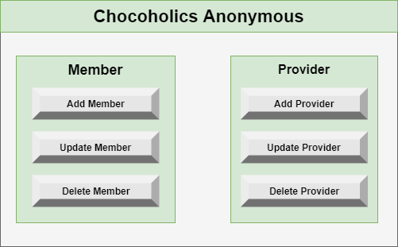

# 2. CRC CARD

|  |  |
| --- | --- |
| Class: ManageMember Control, ManageProvider Control |  |
| Responsibility | Collaborators |
| addProvider(),deleteProvider(),updateProvider() addMember(),deleteMember(),updateMember() | Member Entity, Provider Entity |

# 3. STATE DIAGRAM

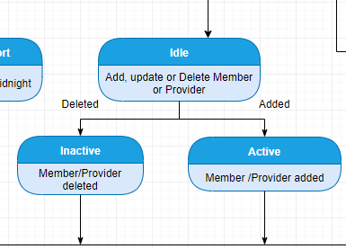

# 4. DFD

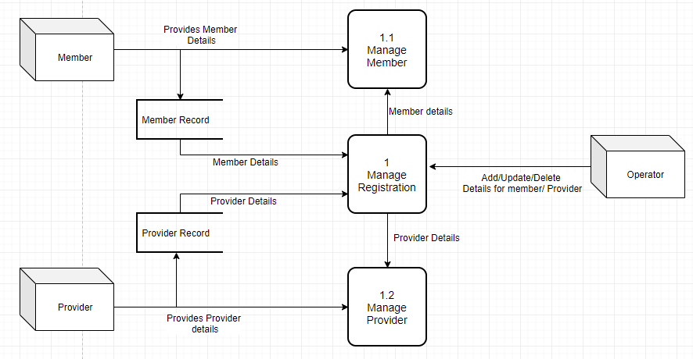

# 5. CLASS DIAGRAM

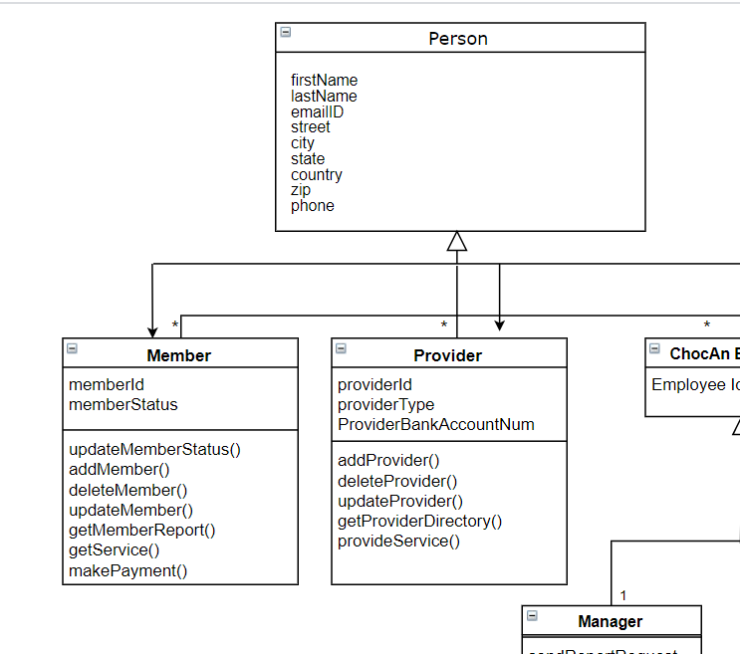

# 6. SEQUENCE DIAGRAM

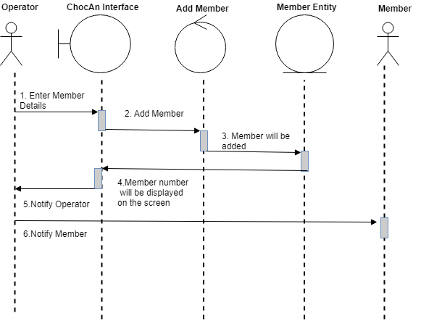

# 7. COMMUNICATION DIAGRAM

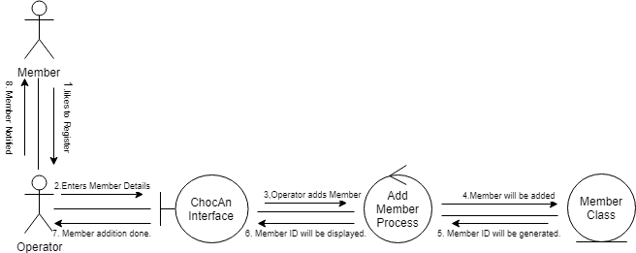

# 8. ROBUSTNESS DIAGRAM

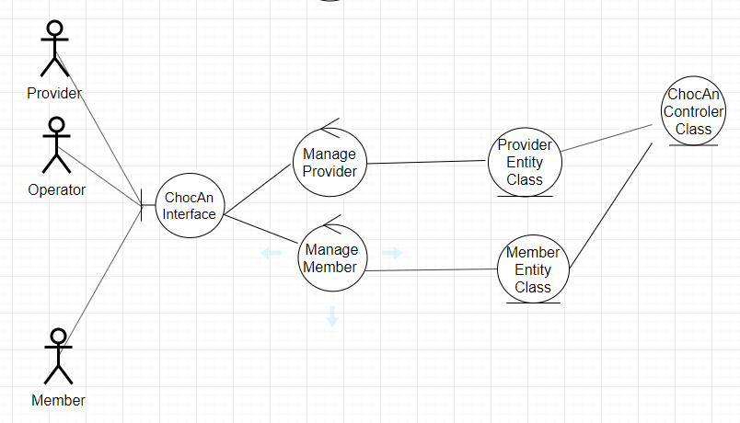

# 9. BUILD ERD

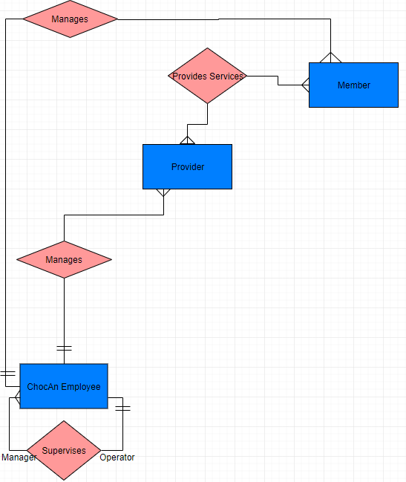

# 10. USE CASE DIAGRAM

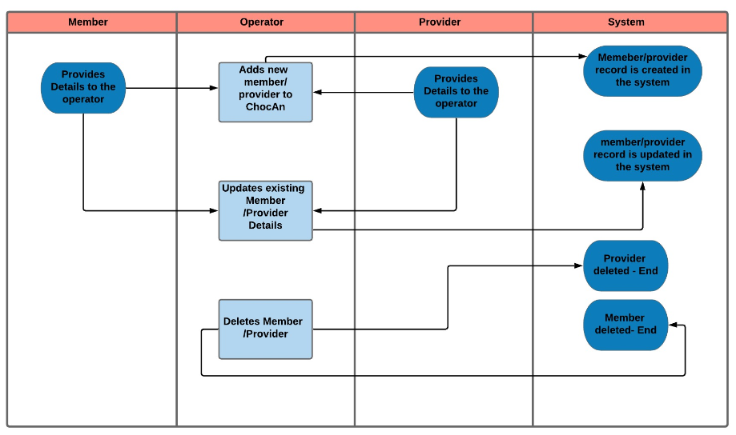

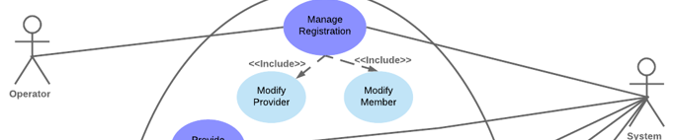

# 11. USE CASE FLOW

* 1. Add Member:
     1. Member will provide the required details like Name, Email address, Phone number, Address to the operator.
     2. Operator will enter the member details on the terminal and submit.
     3. Member will be registered and the details of the record will be saved in the ChocAn data center system.